PSLC Data Shop
Complete Prototype
Think-Aloud User Study
Bold text: spoken to the participant
Regular text: note for the moderator

Test Goals
- Determine if users can use learning curves to make comparisons of treatments.
- Determine if users can find the skills that are relevant to their study.
- Determine if users can effectively use the interface to adjust cutoffs for learning curves. (future)
- Discover difficulties and identify unexpected memory loads. (where do users need information to visually carry forward, indicated by flipping back and forth between pages, by the user forgetting information, or possibly other difficulties )
- Determine if users can create a sample in a dataset.
- Determine whether users can interpret the information we intend to convey with the error report.
- Determine if users can select the data they need to export.

Preparation
- Prepare copy of test plan
- Prepare copy of questions page ( pg 4)
- Prepare prototype (reset to “start state if needed”)

Introduction
- Welcome participant and introduce self (and note taker if applicable)
- Explain usability
- Get permission to speak with them and permission to record.
- Consent Form
- Explain goals: Our goal is to help researchers review tutor data collected from students using computers in the classroom. Your comments will help us know if we can improve on this version of the design.
- Assure the participant that they are not being tested – the interface is being tested. There is nothing the participant can do wrong.
- Ask the participant if they have any questions.
- Tell them they can take a break or quit the session at any time.
- You can ask me questions during the task, but there are some questions that I may not be able to answer until the end of our session.
- Explain and demonstrate “thinking out loud.”
  - If I were thinking out-loud to count the number of windows in my house, I would say: (proceed with task – remember that the more you say now the more they will say during the study)
  - If at any point you forget to keep thinking aloud, I will say “please keep talking.”
- Since these users should have some experience in the domain, try and hold as many questions until the end as possible. If they have a domain-based question, ask them questions about whether they’ve encountered an analogous situation and what they did the last time that happened.
- Ask participant to practice thinking out loud. Explain that if they forget to keep thinking out loud you will remind them by saying “please keep talking.”
  - Think out loud while you multiply the following numbers: 38 and 52

That’s great, you’re doing a great job thinking out loud. We can move into some background questions now.

Background questions

- Have you ever designed or run an experiment before? (This is a warm-up question, it’s OK if they haven’t. This does tell us something about the user’s background knowledge, and may possibly be significant if we find our users are divided on something.)

Analyst: Circle One

Yes No

2) (If they answered “yes” to #1) Can you tell me briefly what you were trying to find out? (short answer, multiple choice, Likert scale, etc.)

Summarize what they tell you. Pay special attention to if they wanted to do a within-subjects (same group compares 2 things) or between subjects (does group A do better than group B on the same thing) study.

3) Have you ever worked with learning curve analysis before? (It’s OK if they have not, but if they say no offer them the “learning curves crash course” sheet as a reference.)

Analyst: Circle One

Yes No

3) Have you taken a college-level course in Statistics or research methods?

Analyst: Circle One

Yes No

Background Information

During this task, you will examine a set of data to answer questions about how students learn. The data was collected from students using computers in the classroom.

The Data Shop contains a variety of reports, each of which may be equally helpful to answer the question at hand. In fact, you will most likely need to consult more than one report to complete the task. Most of these reports are self-explanatory, but one of them, the learning curve report, requires some background knowledge.

Learning curves represent how well students learn on a particular skill or group of skills.. Different learning condition outcomes can be compared by comparing the learning curves for those conditions.

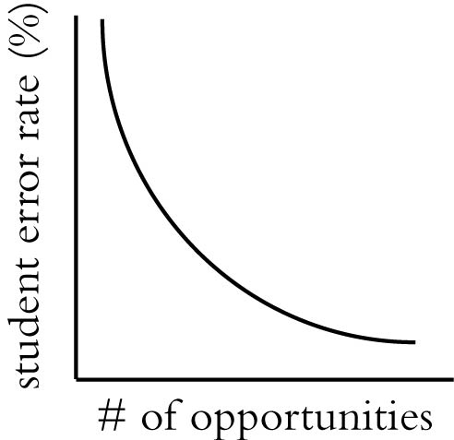
Learning Curve Crash Course

The idea behind learning curves is that, as students gain opportunities to practice a particular concept, their understanding of that concept should increase and the number of errors they make should decrease. The X-axis is the opportunity number and the Y-axis is a measure of learning for students who encountered a particular opportunity. Measures of learning can include the error rate, or the assistance score. For the rest of this tutorial, we will use error rate as a measure of learning.

Points along the X-axis represent the opportunity number where students were given a chance to demonstrate a skill.

Students who succeeded at opportunity 1 may not be asked to demonstrate knowledge of the skill again. Students are removed from the pool as soon as they demonstrate they know a skill. You can expect that the number of students will decrease as the opportunity number increases.

A learning curve for a particular skill plots the error rates of the students at particular opportunity numbers. In order to make comparisons between learning curves easier, it is common practice to compute a power law regression curve.

The curve with a steeper slope represents the condition where learning takes place the fastest.

An equation for a power law regression curve resembles the following:

$$y={\text{ax}}^{−b}$$

- $a$ is the initial error rate at the first opportunity before any treatment has had any possibility to take effect.
- $b$ is the slope of the learning curve. The greater the absolute value of b, the greater the rate of learning.

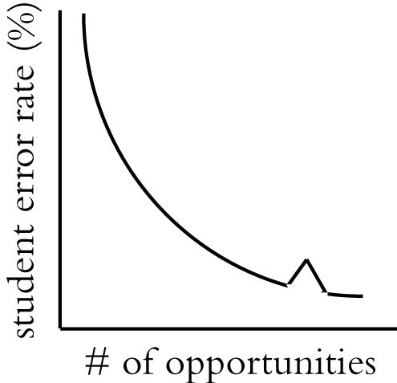
Sometimes, a learning curve momentarily stops sloping downward. This is usually a sign to researchers that another concept was inadvertently included in the problem(s) at which the ‘spike’ occurs, making it more difficult than the others.

Please let the moderator know when you are finished reading this background information.
Scenarios
When we begin I’m going to be handing you pieces of paper with tasks on them. Please show me what you would try to make the data shop do the tasks.

If at any point you would like to stop looking for something, please let me know and we’ll move on. Just try and act the same as you would if you were working at your desk.
Tasks

You are a graduate student working with your advisor on an algebra tutor study.

- Please identify and jot down 2 skills on which the students seem to be improving. Of these 2, which skill are they mastering more quickly?

- Your advisor would like to know if there are any skills where the students appear to be having trouble.

- Please select one of the skills that appear to be troubling.

a. For this skill, what problem had the most students get the problem incorrect?

b. What were the 3 most common errors for this problem?

- Your pilot study for the tutor revealed several common mistakes that students made. For those, you wrote feedback messages for the tutor to give the future students when they made these mistakes. Now, for this new data, find the 3 most common unexpected mistakes.

- In part of the study, one of the classes was given diagrams along with the problems and another was given only text. In School 71, you want to look at how Class 1’s performance compared with that of Class 2. How would you set the data shop to examine the performance of only these two classes?

- Please create a sample for Class 1 labeled “diagrams”

- Please create a sample for Class 2 labeled “control”

- You want to study how students are using hints as they use the tutor. There is no standard report for this research question. With each hint on a particular step, the hints become more explicit. Extract all of the students who used hints on the problems. You will need the hint level information to perform your analysis.

Post-task Questions
- Now that you’ve spent some time with the data shop, what are your impressions?

- What is the best thing about it?

- What is the worst?

- How would you make it better?

Thanks for taking the time to help us with this. Your information will really help us make this better. If you think of anything later that you would like to tell us please email:

__________________________________@andrew.cmu.edu

